SIMATS ENGINEERING (SAVEETHA SCHOOL OF ENGINEERING)
Department of Computer Science and Engineering
CO1 ASSESSMENT TOOL 1 – Case Study Analysis

Course Code: | CSA1063 | Course Title: | Software Engineering
CO Assessed: | CO1 AT 1 | Assessment: | Assessment Tool 1 – Case Study Analysis
Weightage: | 20% | Total Marks: | 25
CO1 Statement: | Apply advanced methodologies and agile project management techniques to manage software projects effectively
Student Name: | Jasim Asmaan A | Reg. No.: | 192421060
Date: | 22-07-2026 | Duration: | 60 minutes

Annexure A – Case Study Analysis
TITLE: Case Study Analysis on Smart City Domain:Smart Disaster Alert and Emergency Response Coordination System

Case Study Analysis Questions
  - Understand the Problem Statement
Explain the problem in your own words.
Nowadays, due to climate change and global warming,natural disasters such as floods,cyclones,earthquakesand landslides are becoming more frequent. In many cases, people do not receive warnings on time, which leads to loss of lives and property. A smart disaster alert system can provide early warnings and help emergency teams respond quickly.
  - Identify the objectives of the proposed system.
Objectives :
➢ Provide early disaster alerts in real time.
➢ Predict disaster severity using AI and location data.
➢ Reduce loss of lives and property.
➢ Improve coordination between rescue teams and authorities.
➢ Provide nearby shelter, food, and first-aid information.
➢ Improve public safety and emergency response.
The system can be used in disasterprone areas such as cities, towns, and villages. It supports disaster monitoring, emergency alerts, rescue coordination, and public communication. In the future, it can also be integrated with IoT devices and advanced AI technologies.

  - Explain the problem in your own words.

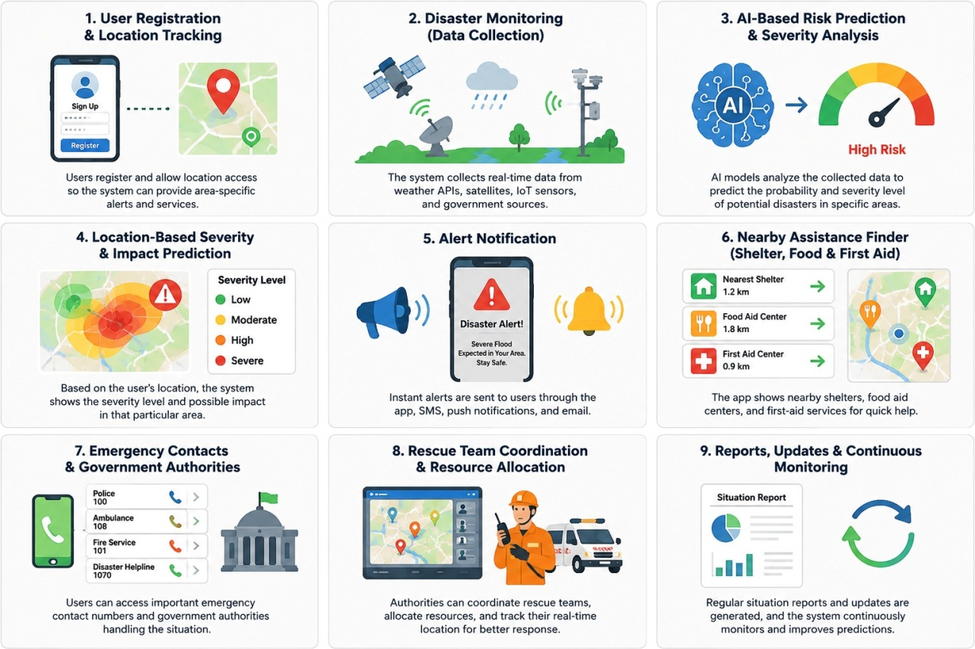

- Identify Key Stakeholders and Challenges
2.1 Identify all the stakeholders involved in the system.
Key Stakeholders :
Each stakeholder plays an important role in disaster monitoring, communication, and emergency response.
- Citizens
- Disaster Management Authorities
- Rescue Teams
- Police Department
- Fire & Rescue Department
- Hospitals & Ambulance Services
- Weather Department
- Government Authorities
- System Administrators
- Software Developers
2.2 Explain the roles and responsibilities of each stakeholder.
Citizens receive disaster alerts and follow safety instructions. Disaster management authorities monitor disasters and coordinate rescue operations. Rescue teams provide emergency assistance, hospitals treat injured people, weather departments provide weather updates, and administrators maintain the system.
  - Discuss the major challenges and issues faced by the stakeholders.
The major challenges include delayed warnings, poor communication, inaccurate information, and lack of coordination between emergency departments. During disasters, network failures and limited resources can also make rescue operations more difficult.

- Delayed disaster warnings.
- Fake news and misinformation on social media.
- Poor communication between departments.
- Lack of a single authorized disaster platform.
- Limited rescue resources during emergencies.
- Network failures in affected areas.

  - Describe the existing system or current process.
Currently, disaster alerts are mainly shared through television, radio, SMS, and social media. Sometimes, social media spreads fake or unverified information, creating confusion among the public. There is no proper authorized application that provides location-based alerts, emergency contacts, nearby safetycentres, and government updates in one place.
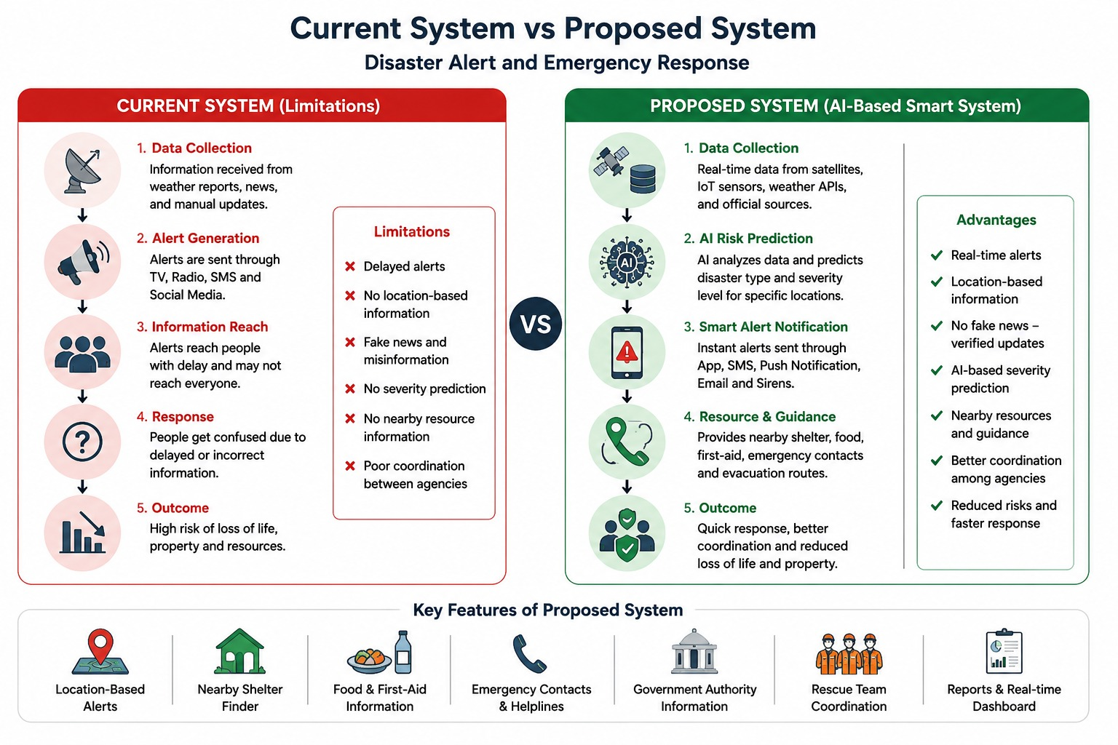

  - Identify its strengths and limitations.
The existing system is simple and can reach many people through public media. However, it does not provide real-time monitoring or AI-based prediction. It also depends on manual communication, which can delay emergency response.

- Provides alerts through multiple communication channels.
- Supports basic emergency response activities.
- Easy access through television, radio, and SMS.
- Helps spread disaster awareness.

Limitations

- Delayed emergency alerts.
- Fake or unverified information on social media.
- No location-based severity prediction.
- Lack of centralized coordination.
- Limited real-time monitoring.
  - Analyze the problems or gaps that need to be addressed.
The current system cannot accurately predict disasters or provide location-specific alerts. Communication between different departments is not always efficient. A faster and more intelligent system is needed to improve disaster management.
- Delayed disaster detection.
- No AI-based prediction system.
- Lack of nearby shelter information.
- No food and first-aid guidance.
- Poor communication with rescue teams.
- No unified emergency application.
- Propose a Suitable Solution Using Software Engineering Principles
  - Design a software-based solution for the given problem.
The proposed solution is an AI-based mobile and web application that collects weather, satellite, and location data to predict disasters. Based on the user's location, the system predicts the disaster severity level, sends early alerts, and provides information about nearby shelters, food and first-aid centres, emergency contact numbers, and the government authorities handling the situation.

  - Describe the major functional modules of the proposed system.
- User Registration & Login
- Disaster Monitoring
- AI-Based Risk Prediction
- Location-Based Severity Prediction
- Emergency Alert Notification
- Nearby Shelter, Food & First-Aid Finder
- Emergency Contact & Government Authority Information
- Rescue Team Coordination
- Resource Allocation
- Report Generation
- Admin Dashboard
  - Identify the functional and non-functional requirements.
Functional Requirements:
- User Registration and Login
- Disaster Monitoring
- AI-Based Risk Prediction
- Location-Based Severity Prediction
- Emergency Alert Notification
- Rescue Team Coordination
- Resource Allocation
- Nearby Shelter & First-Aid Finder
- Emergency Contact Information
- Report Generation
Non-Functional Requirements:
- High Security
- Fast Performance
- Reliability
- Scalability
- Maintainability
- User-Friendly Interface
- High Availability
- Data Accuracy
- Quick Response Time

  - Explain how software engineering principles such as modularity, scalability, maintainability, reliability, usability, and security are incorporated into your solution.
The system follows modularity by separating different functions into individual modules. Scalability allows it to handle many users during emergencies. Security protects user data, while maintainability makes updates easier. Reliability and usability ensure the system works effectively during disaster situations.
- Modularity: Separate modules for alerts, monitoring, rescue, and reports.
- Scalability: Supports a large number of users during disasters.
- Maintainability: Easy to update and add new disaster features.
- Reliability: Ensures continuous monitoring and alert generation.
- Usability: Simple interface for citizens and government authorities.
- Security: Protects user information using secure authentication.
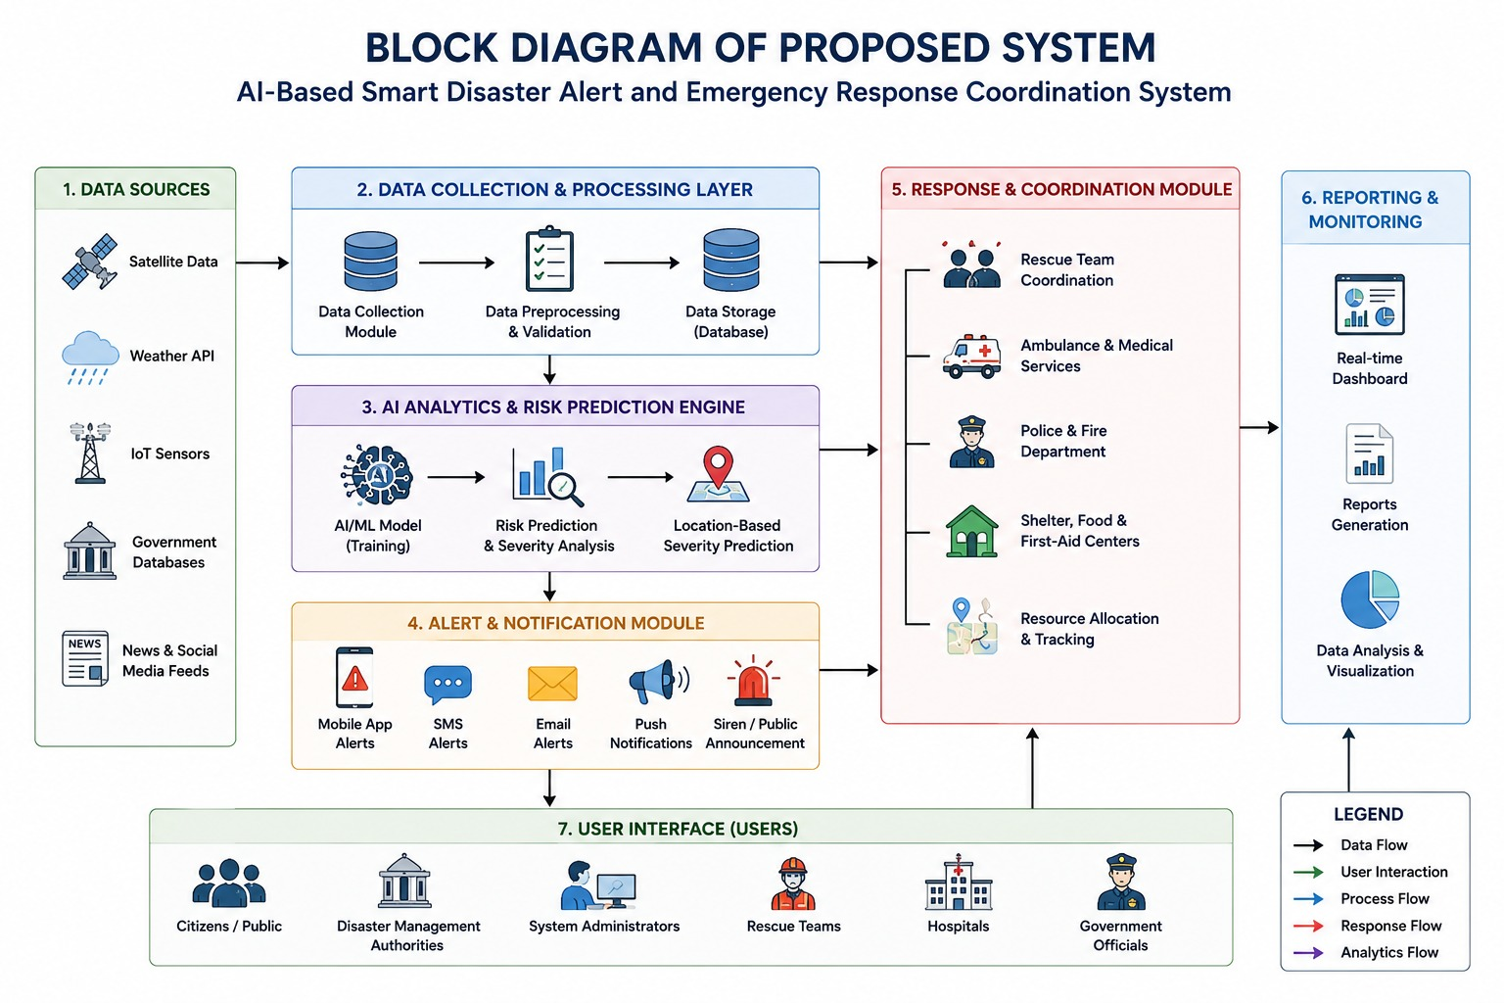

- Justify the Chosen Methodology/Framework
  - Select an appropriate Software Development Life Cycle (SDLC) model or software development framework (e.g., Agile, Scrum, Waterfall, Spiral, DevOps).
The Agile SDLC model is chosen because it allows the project to be developed step by step with regular testing and improvements. It is suitable for this system since disaster management requirements may change over time, and new features can be added easily. Agile also encourages teamwork and regular feedback, which helps identify problems early and improve the system. This makes the software more flexible, reliable, and easier to maintain in the future.
  - Justify why the selected methodology/framework is suitable for the proposed system.
Agile allows the project to be developed in small stages with regular feedback from users. It helps identify and fix problems early in the development process. This makes the system more flexible and reliable.
- Supports continuous development.
- Easy to add new disaster features.
- Encourages regular user feedback.
- Reduces project risks.
- Supports continuous testing.
- Delivers software faster.

  - Explain how it supports successful project development and maintenance.
Agile supports teamwork, testing, and continuous improvement in the whole process. The program becomes easier to maintain and modify without impacting the whole system. Thus, it stays efficient for a long time.
- Discuss Expected Outcomes and Limitations
  - Describe the expected benefits of the proposed solution.
The system provides accurate location-based disaster alerts and predicts the severity of disasters before they occur. It helps people quickly find nearby shelters, food distribution centers, first-aid facilities, emergency contact numbers, and government support. This reduces confusion and enables faster emergency response.
- Early disaster prediction.
- Faster emergency response.
- Reduced loss of life and property.
- Better communication among authorities.
- Accurate location-based alerts.
- Improved public safety.
  - Explain how the solution addresses the identified challenges.
The system reduces the spread of fake news by providing alerts only through an authorized platform. AI-based location analysis predicts the severity of disasters in different areas and guides users to nearby emergency services. It also improves coordination between government authorities and rescue teams.
  - Discuss potential risks, implementation challenges, and limitations.
The system depends on internet connectivity, weather data, and sensors for accurate predictions. Technical failures or incorrect data may affect its performance. The initial setup cost and maintenance of the system can also be high.
- High implementation cost.
- Internet dependency.
- Sensor failures.
- Incorrect AI predictions.
- Data privacy concerns.
- Continuous system maintenance.

  - Suggest possible future enhancements.
In the future, the system can include drone surveillance, satellite image analysis, multilingual voice alerts, offline emergency notifications, and live tracking of rescue teams. It can also use more advanced AI models to improve disaster prediction accuracy and provide personalized safety
recommendations.
- Drone-based disaster monitoring.
- Satellite image integration.
- Advanced AI prediction models.
- Offline emergency alerts.
- Multi-language support.
- Live rescue team tracking.
- IoT sensor integration.

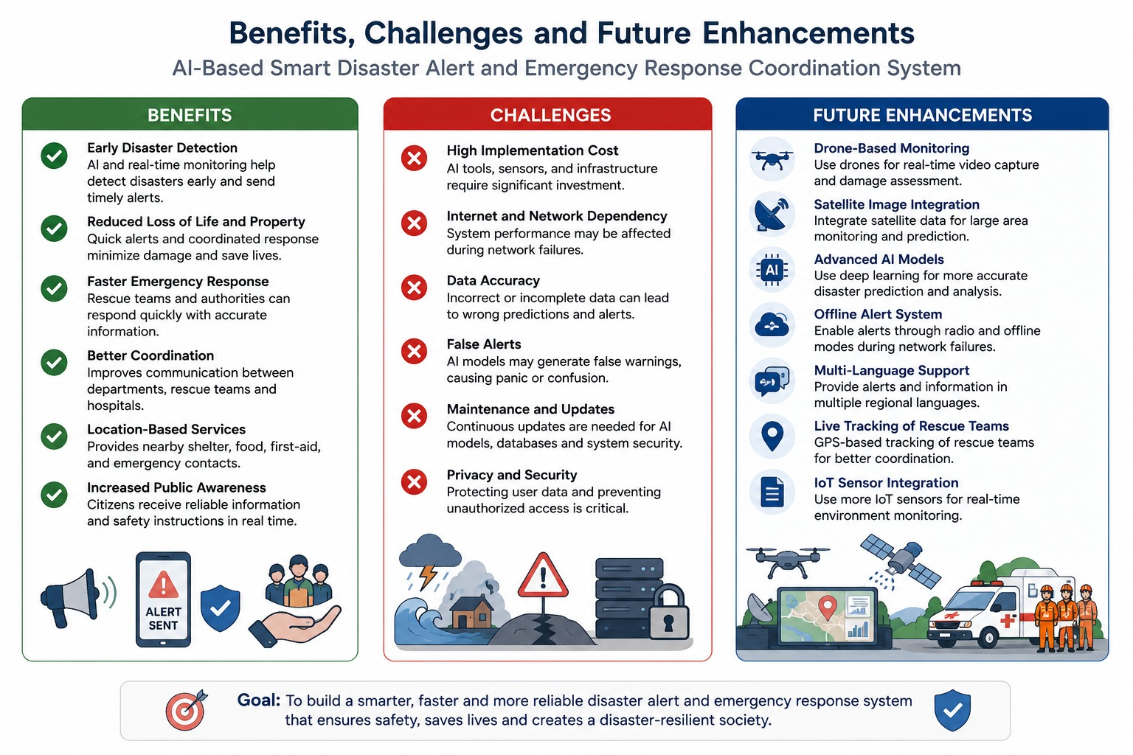

Expected Deliverables
Each student should submit:
- Case Study Analysis Report
- Problem Analysis
- Stakeholder Analysis
- Current System Analysis
- Proposed Software Solution
- SDLC/Framework Justification
- Expected Outcomes and Limitations
This assignment evaluates the student's ability to analyze a real-world problem, apply software engineering principles, select an appropriate development methodology, and design a feasible software solution. It is suitable as an implementation-oriented case study assessment aligned with Software Engineering course outcomes.
Criteria | Excellent (4 Marks) | Good (3 Marks) | Satisfactory (2 Marks)
Problem Understanding | Clearly explains the problem, objectives, and scope with complete understanding. | Explains the problem with minor omissions. | Basic understanding with limited explanation.
Stakeholder & Challenge Analysis | Identifies all stakeholders, their roles, and challenges with clear analysis. | Identifies most stakeholders and challenges with adequate analysis. | Identifies only a few stakeholders or challenges.
Current System Analysis | Thoroughly analyzes the existing system, strengths, weaknesses, and identifies all gaps. | Good analysis with most strengths and weaknesses identified. | Limited analysis with partial identification of issues.
Proposed Software Solution & Software Engineering Principles | Proposes an innovative, feasible solution applying appropriate software engineering principles (modularity, scalability, maintainability, security, etc.). | Suitable solution with good application of software engineering principles. | Basic solution with limited application of software engineering principles.
Methodology/Framework Justification | Selects the most suitable SDLC/model/framework and provides strong technical justification. | Suitable methodology selected with adequate justification. | Methodology selected but justification is weak.
Expected Outcomes & Limitations | Clearly explains expected outcomes, benefits, limitations, and future improvements. | Explains outcomes and limitations with minor omissions. | Limited discussion of outcomes or limitations.

